SX440
Generator Automatic Voltage Regulator Operation Manual

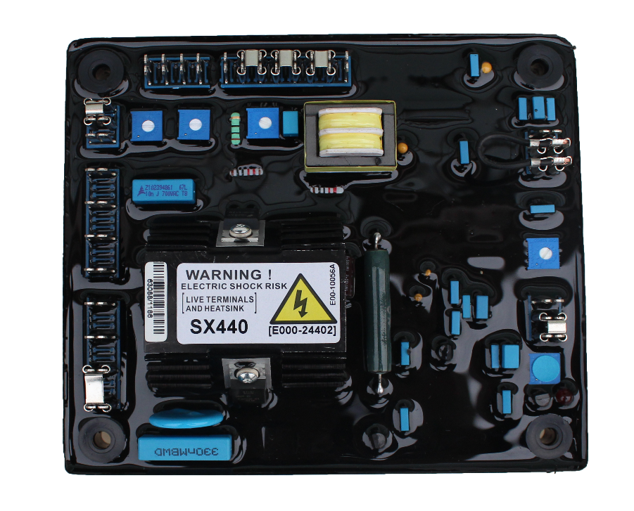

Self Excited Automatic Voltage Regulator

_

1 SX440

SPECIFICATION

Sensing Input
Voltage 190 ~ 264 VAC, 1 phase 2 wire
Frequency 50 / 60 Hz, selectable

Output
Voltage Max. 90 VDC @ 207 VAC Current Continuous 4A
Intermittent 10A for 10 sec.
Resistance Min. 15 ohm

Voltage Regulation
< ± 1% ( with 4% engine governing )

Voltage Build-up
Residual voltage at AVR terminal > 5 VAC

Thermal Drift
0.05% per °C change in AVR ambient

External Volts Adjustment
±8% with 1K ohm 1 watt trimmer

Unit Power Dissipation
Max. 12 watt

Under Frequency Protection (Factory Setting)
Set point 95% Hz
Slope 170% down to 30 Hz

Soft Start Ramp Time
2 sec.

Analogue Input
Sensitivity 1V for 5% generator volts Input Resistance 1K ohm
Max. Input ± 5 VDC

Quadrature Droop Input
Burden 10 ohm
Max sensitivity 0.07 A for 5% droop (PF=0) Max. input 0.33 A

Dimensions
150mm L * 135mm W * 40mm H

Weight
418g ± 2%

WIRING
- K1, K2 : Field input external switch terminals. Linked for normal operation.
- P2, P3 : External power input terminals.
- 3, 2 : Sensing input terminals.
- 1, 2 : External VR terminals. Linked for useless.
- X,XX : X connect to field (+), XX connect to field (-).
- S1, S2 : Droop CT input terminal.
- A1, A2 : VAR/PF controller input.
- A, B, C : Link A, C for under 90KW.
Link B, C for 90 ~ 550KW. Link A, B for over 550KW.
- J1~J8 : Jump select terminals, 2-3,4-5,6-7. please refer to Figure 2 and Figure 3.

ADJUSTMENT

Voltage Adjustment
The generator output voltage can be altered by adjustment of the volt VR on the AVR board, or by the external trimmer (1KΩ) if fitted.

- The terminals 1&2 must be linked if no hand trimmer.
- Before start the generator, please turn the Volt trimmer on the AVR board fully anticlockwise Turn the external trimmer to midway position.
- Turn the stability trimmer on the AVR board to midway position.
- Connect a voltmeter to generator output voltage terminals.
- Start generator set and run on no load at nominal frequency 50 ~ 53Hz or 60~63Hz.
- If the red Led is illuminated, refer to the under frequency roll off adjustment.
- Carefully turn volt trimmer clockwise until rated voltage is reached.

Stability Adjustment
If a replacement AVR has been fitted or re-setting of the stability control is required, turn the stability trimmer slowly clockwise until the output voltage is steady, on or off load.

Droop Adjustment
Generator intended for parallel are fitted with a quadrature droop CT with provides a power factor dependent signal for the AVR. The CT is connected to S1, S2 on the AVR. The Droop adjustment is normally present in the works to give 5% voltage droop at full load zero power factor. Clockwise increases the amount of CT signal injected into the AVR and increases the droop with lagging power factor. With the control fully anticlockwise there is no droop.

Trim Adjustment
An auxiliary input is provided to connect to A1, A2. It is designed to accept DC ± 5V.Turn the TRIM trimmer fully anticlockwise has no effect, Clockwise it has maximum effect.

4. FIELD FLASHING
When the regulator is operated with the generator for the first time, the polarity of residual magnetism may be reversed or too small to achieve the necessary build-up voltage for the regulator. If reversing the field connections does not induce build-up, and the residual voltage is less than the specified value of 5 VAC, shut down the Prime-mover and proceed with the following steps :

- With the Prime-mover at rest and the regulator’s field output wires disconnected, apply a DC source ( NOT grounded ) of no more than 3~12 VDC with Positive to X and Negative to XX, in series with a current-limiting resistor of 3~5 ohms 20 watt. (The set battery is a suitable source.)
- Allow approximately 3 seconds before removing the DC source.
- Disconnect the AVR AC power input terminals and restart the generator, re-measure the residual voltage. If this voltage is greater than 5VAC, reconnect voltage regulator, and voltage build-up should be successful. If measured less than 5VAC, repeat steps 1 and 2.
- If residual voltage is greater than 5VAC, but AVR still unable to build up voltage, please replace with another AVR.

WARNING
Overly field flashing may damage the AVR or generator excitation winding.
Please make sure you have read and understand the contents of the instruction manual prior to installation. Incorrect wiring connection may result in irreversible damage to the product and other equipments.

PARALLEL FUNCTION

Parallel Compensation
- When it is required to operate the regulator in parallel with an isolated or utility bus, in addition to the regulator provisions, a 10VA current transformer (CT) is required ( See Figure 3 ). The CT is connected in a generator line and should deliver from 1 amperes secondary current at rated load.
- The phase relationship of CT signal to the regulator sensing voltage must be correct or the system will not parallel properly. The CT must be installed in the line of the three phase generator that does not supply sensing to the regulator.

Reactive Droop Compensation
- For reactive droop compensation, connect the CT to it’s respective regulator as shown on Figures 3.
- A unit-parallel switch shorts the parallel CT secondary to prevent any droop signal from being injected into the regulating system during single unit operation. The switch may not be required on parallel droop compensation applications where a voltage drop is not objectionable.

ATTENTION
- AVR can be mounted directly on the engine, genset, switchgear, control panel, or any position that will not affects operation. For dimension reference, please see Figure 1.
- All voltage readings are to be taken with an average-reading voltmeter Meggers and high-potential test equipment must not be used. Use of such equipment could damage the AVR.

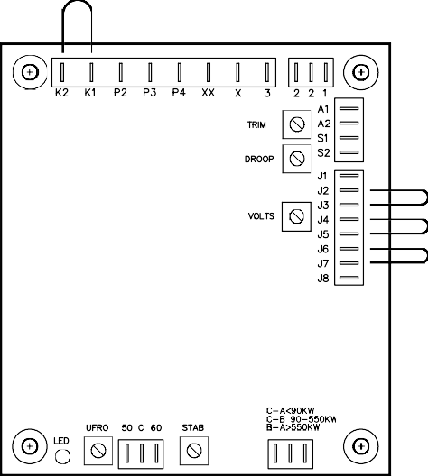
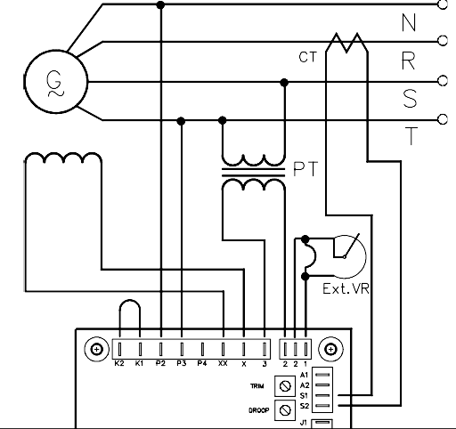
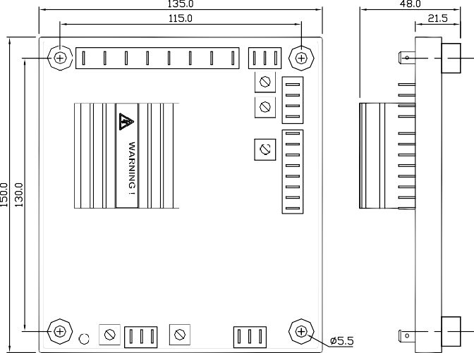
Figure 1 Outline Drawing UNITS : mm
SX440
TRIM

DROOP

VOLT
C-A < 90KW C-B 90-550KW B-A > 550KW
UFRO
STAB
LED
C B A
High Temperature
Figure 2 Bypass Drawing Figure 3 Wiring Drawing

6. TROUBLE SHOOTING

SYMPTOM | CAUSE | CORRECTION
Voltage does not build up | Engine speed is too low | Please refer to the Generator Manual
 | wires are not connected well | Please refer to Figure 2
 | Defective Generator | Please refer to the Generator Manual
Out voltage low | External VR broken | Check wiring and testing VR
 | Terminal 1&2 not linked | Please linked terminal 1&2
 | Terminal 3&2 no sensing input | Please refer to Figure 2
 | Under frequency | Please refer to the Generator Manual
 | Defective Generator | Please refer to the Generator Manual
Out voltage high | AVR adjustment not well | Please refer to voltage adjustment page
 | Defective Generator | Please refer to the Generator Manual
※ Use only original supplied spare protection fuse for fuse replacement.
※ Please accept our sincere apology if any modification in performance, specification or appearance is made without prior notice.

